Support Vector Regression:

**If Kernel=’linear’**

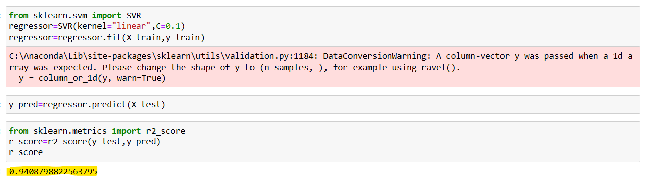

This kernel looks better model since r_score value is near to 1.

If C value is changed to C=1.0 then r_score value decreases to 0.8, Similarly for below kernel types value is changed based on C value.

**If Kernel=’rbf’**

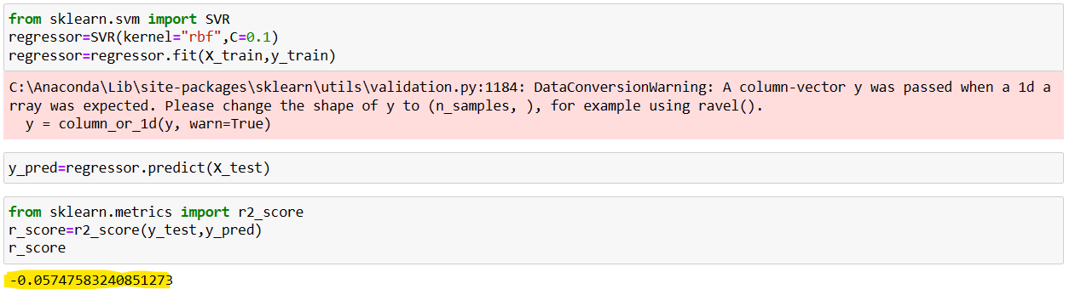

This model doesn’t look good and it as negative value.

**If Kernel=’poly’**

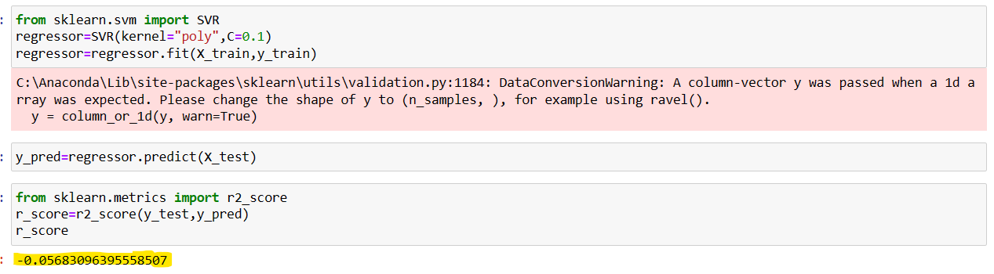

This model doesn’t look good and it as negative value.

**If Kernel=’sigmoid’**

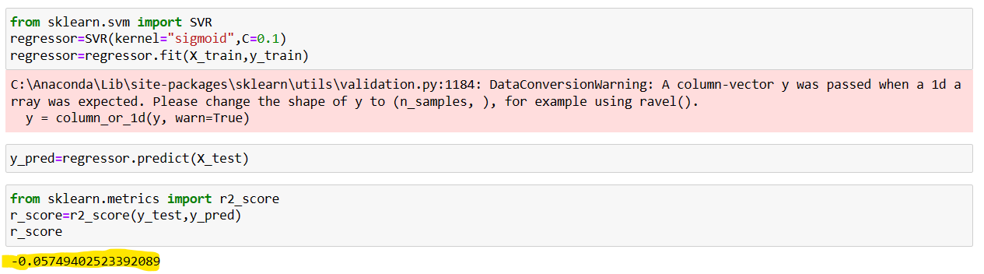

This model doesn’t look good and it as negative value.

**If Kernel=’precomputed’**

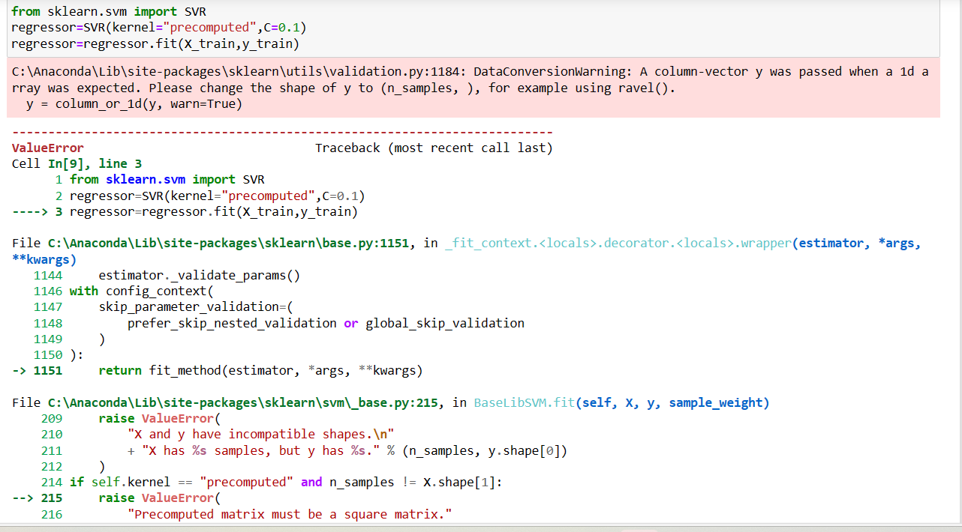

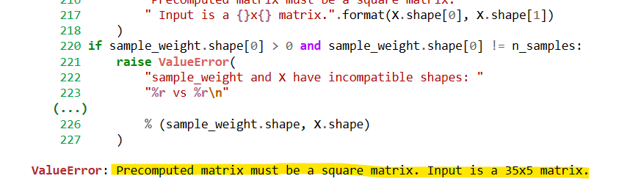

Since this input has 5 columns and 35 rows this cannot be done using “precomputed kernel”